Exercise 2 OLS

* Calculate the correlation between Y and X1



This result differs a lot from the coefficient (1.2) in the true model.

* Calculate the coefficients on this regression



* Calculate the standard errors

(1). Using the standard formulas of the OLS:



(2). Using bootstrap with 49 and 499 replications respectively:

with 49 replications:

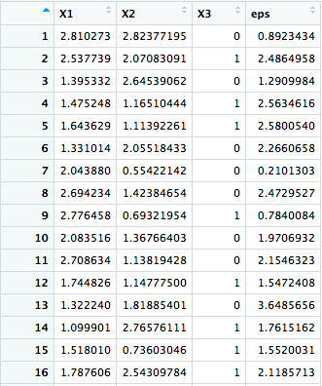

with 499 replications:

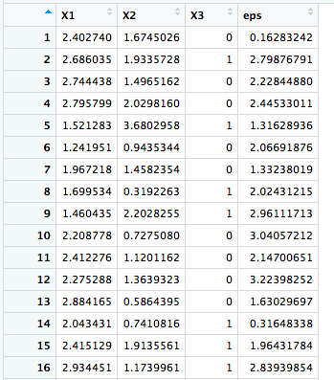

Exercise 3 Numerical Optimization

* Write a function that returns the likelihood of the probit

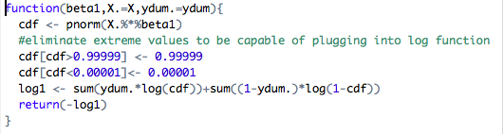

* Steepest ascent optimization



The estimated results are pretty close to the true parameters

Exercise 4 Discrete Choice

* Interpret and compare the estimated coefficients, how significant are they?

Probit estimation:

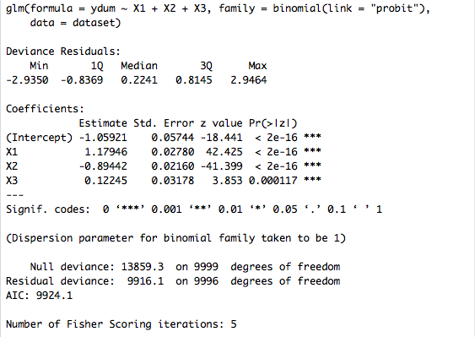

Logit estimation:

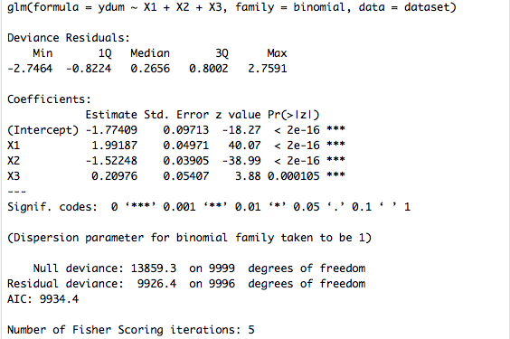

Linear estimation:

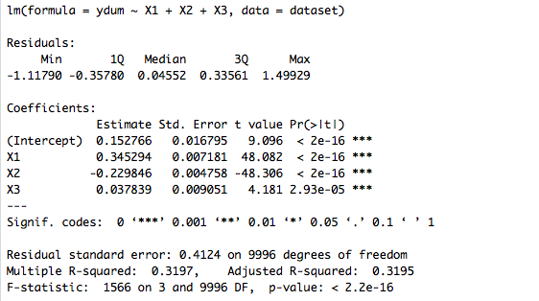

According to the test result, coefficient estimations of linear probability model is closer to the true model than probit and logit models. The results of significant test are uniform across three models, with all coefficients being strongly significant.

Exercise 5 Marginal Effects

* Compute the marginal effect of X on Y according to the probit and logit models

Please check the excel output “probit marginal effect” and “logit marginal effect”

* Compute the standard deviations using

1. Delta method

(a). probit variance-covariance

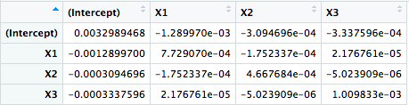

(b). logit variance-covariance

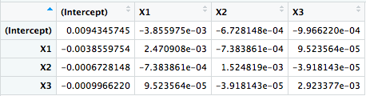

1. Bootstrap

(a). probit

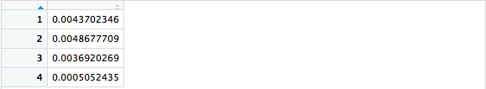

(b). logit

